MILLHOLLOW REAL MAC COY (IDC1) 372414004597422.
IHR-4597422. Colour: Grey. Year: 2006. Height: 169.0 cms. Girth: 206.0 cms. Bone: 22.8 cms. Year Classified: 2014.

 |  | PRIDE IF SHAUNLARA, (IDC1)
 | KING ELVIS, (IDC1)
ANNAGHDOWN STAR, (IDC1) |  | TOAMES BEAUTY, (RID)
 |  | GLENSIDE, (IDC1)
 | ANNAGHDOWN GOLD, (RID)
 |  | ANNAGHDOWN ROSE, (RID)
 |  | BLUE PETER, (IDC1)
 | BLUE HENRY, (IDC1)
ROMA BLUE WIND, (RID) |  | KNOCKAVAHER PRIDE, (RID)
 |  | WINDGAP HERO, (IDC1)
 | KILTOWRA GLEE, (RID)
 |  | BLAZEN GIRL II, (ISH)

Breeder: Moira McKenna.
Owned By: Roy Butler, 1 Corbally Road, Aldergrove, Crumlin, Co Antrim BT29 4ER
Service Fee: On application.
Telephone: 02894464355 Mobile: 07761179098
email: royshamrockstud@utvinternet.com

This stallion was classified as Class 1 following inspection by Horse Sport Ireland. The stallion passed the Horse Sport Ireland stallion veterinary examination and x-ray requirements.

Inspection Panel Summary: He is an attractive well made horse with quality and depth. He is a nice stamp of an Irish Draught horse. He displayed good active paces and showed sufficient athleticism.

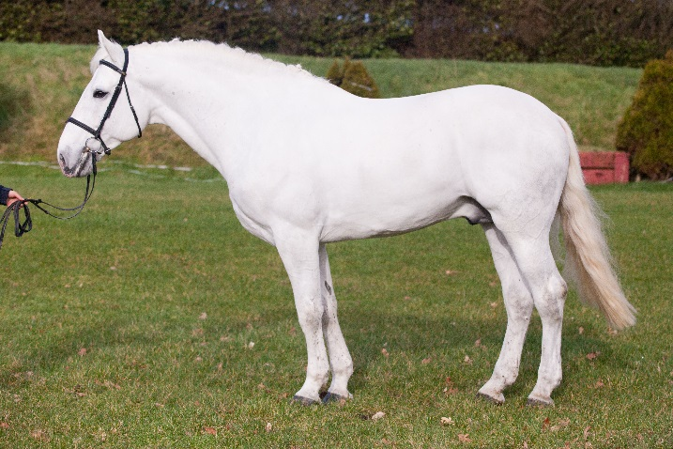

INSPECTION SCORES

 | Conformation:  /100 | Type:  /100 | Movement:  /100 | Athleticism:  /100
Min. Required Score | 70 | 65 | 70 | 65
Points awarded on inspection | 75 | 75 | 70 | 65
Pedigree bonus points awarded | -- | -- | - | --
Total Score | 75 | 75 | 72.5 | 65

