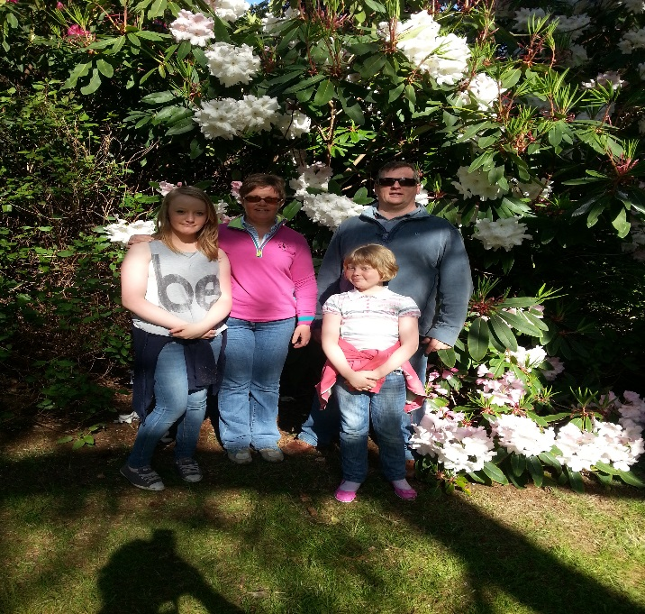

Name: Katie Burns
Age: 15
School: Aughnacloy High School
Education: Studying for GCSE’s
TD Discipline: Dressage

Mum, Dad Me and sister Erin

Hi, my name is Katie Burns and I am a 15 year old pony dressage rider. My current dressage pony is an 11 year old German Riding pony Caracas II, (aka Spud) by the famous German foundation Welsh stallion Constantin.
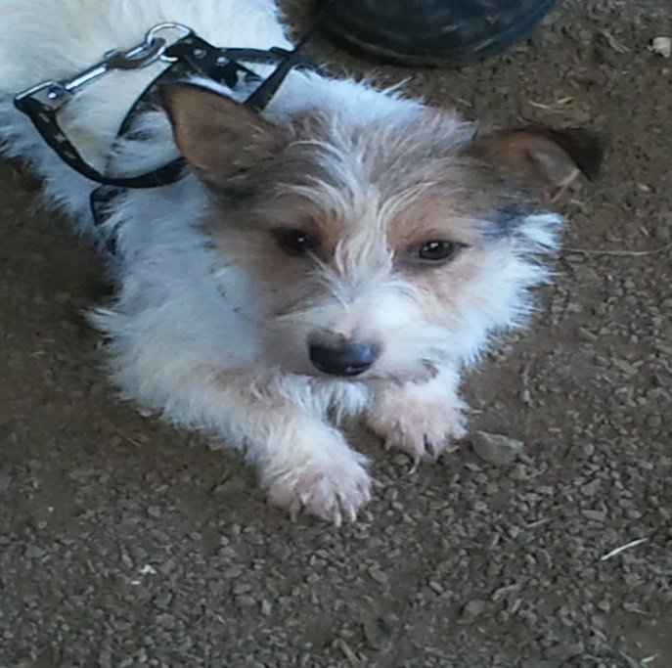
Princess the dog - my best friend and travel companion!

Biography
I started riding at Moy Riding school aged 6 and competed in working hunter competitions all over Ireland on my grey pony George of the Jungle. In my early riding career I competed at side saddle, one day eventing, working hunter and took part in South Tyrone foxhound’s hunts.
I trained with Ian Woodhead and Kate Lewis in England and brought my coloured cob Harry Hoot from prelim to elementary dressage. We were National under 25 champions and won a silver spurs bursary twice.
More recently Spud and I train with Alison Mastin Moore and are part of the Irish pony dressage team. We started competing at medium level in January 2014 and have completed our first International CDI 3* gaining European qualification.
I attend Aughnacloy High School, and am studying for my GCSE’s, hoping to eventually complete teacher training.

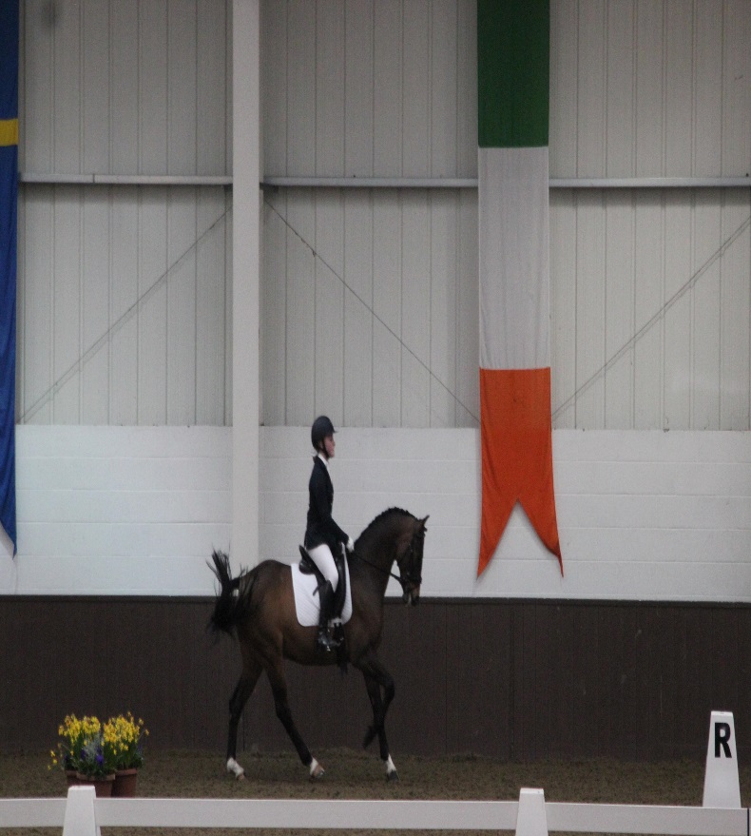
Caracas and Katie in Addington CDI-P April 2014
