Name: Megan McGrath
Age: 19
DOB: 20/10/94
School: Ballyclare High
Education: Physiotherapy Student @ University of Ulster
Home: Ballyrobert Co. Antrim
TD Discipline: Dressage

The story so far…
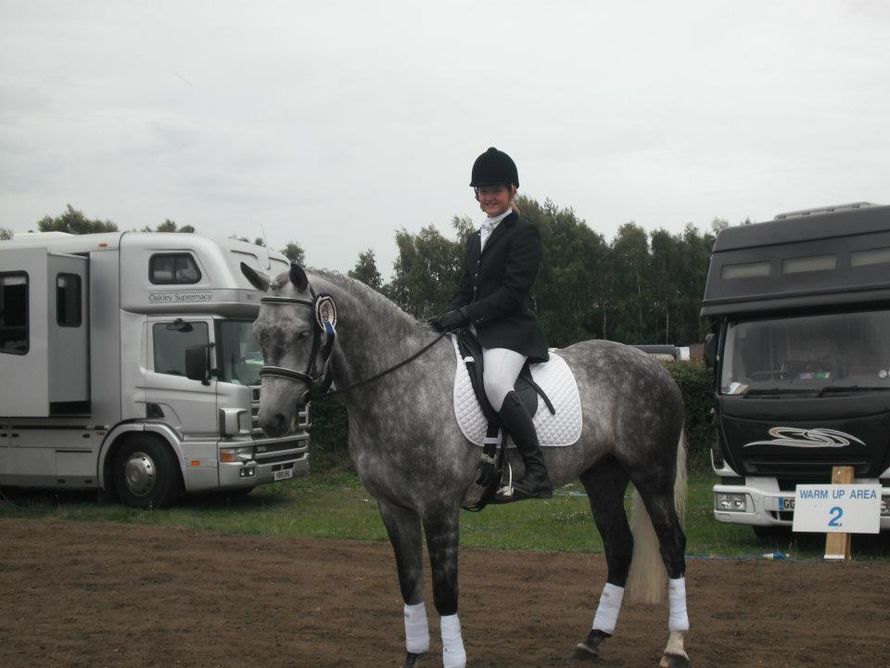
I started riding around the age of 10 and was fortunate to get my first pony on loan, The Ferryman, who pretty much taught me how to ride. I competed in mostly working hunter, dressage and the odd one day event. I soon discovered that dressage was my favourite discipline. The Ferryman took me down the line of registered dressage- one of only a few kids who were doing registered dressage at the time. I was fortunate to have success with him and got the opportunity to ride on the BYRDS U25 dressage team at Myerscough 2008.

From a 13.2h schoolmaster I progressed onto a 16.1h 4 year old (Theo) - a steep learning curve but we learnt so much together. In 2010 we qualified for the Hickstead Dressage Masters and came 3rd in our class. In September of the same year we won the U25 Dressage Championship at the National Championships in Cavan.

Megan and Dhumavarna at Hickstead 2010

Christmas of that year Santa brought me a new coach, ex double Olympian and 11 times Irish National Champion, Heike Holstein. It is great to train with such an experienced and knowledgeable coach who has taken me to the next level in dressage and fingers crossed will continue to do so.
2011 arrived and our hard work seemed to be paying off when we took the Novice Championship title at the National Championships in Cavan and another BYRDS’s U25 competition at Rowallan, Scotland where we finished in the top ten despite an incident with a hidden photographer!
The 2012/2013 season was curtailed by my exams but we still achieved 3rd and 2nd in the Elementary National Championships at Cavan.
In 2013 I was fortunate to gain a place on the HSI/SNI Talent Development Squad, which for the first time included dressage. This has been a great experience, from the high level of quality coaching through to the informative and useful classroom sessions. It has also been enjoyable training with the rest of the Disciplines, and getting to know everyone a bit better.
March 2014 saw a new addition to the family in the form of Jac. On our first outing together in May we managed a credible 4th place at the NI Festival, where I also won the Elementary Championship with Theo. I am looking forward to working and developing a partnership with Jac and progressing to the next level with Theo.
Contact Me:
Email: Meganmcgrath2010@yahoo.co.uk

Dhumavarna enjoying some down time on the beach in Castlerock

Romano Frèrejacques (the new addition)

