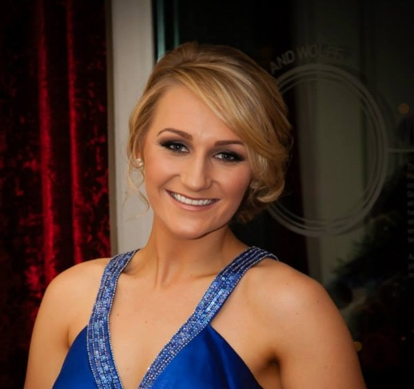

Name: Patricia Stewart
Age: 24
DOB: 28/06/1990
School: Wallace High School
Height: 5”9
Home: Ballymoss Stud, Lisburn, Co. Antrim
TD Discipline: Show Jumping

INTRODUCTION
Thankfully I have been lucky to have the consistent support of my parents as owners and producers of quality horses. Whilst I gained my basic equestrian education in ponies, it was when I turned 14 years of age that I knew horses were going to be my life & my career. It was at this age that I bought my first horse, Best Touch, from my mother, Mavis, with all of my savings - as every time he went competing, there were always people interested in him & asking to buy him. Best Touch competed to Grand Prix level but was very sadly retired due to injury in 2013, but he was instrumental in developing my skills & passion in this challenging sport.
My mother has been my inspiration & motivator; she has been involved in the horse industry for most of her life and successfully competed throughout Ireland, England and Scotland. Alongside competing, she also specialised in breaking and producing young horses, many of which were sold to international buyers. This success and the fact that she is a well-known and respected coach, has resulted in a healthy flow of clients, looking for help with their horses or interested in buying a potential star.
I was a pupil at Wallace High School in Lisburn and I went on to complete my A level education. Taking a gap-year from university, I finally persuaded my parents that it was show jumping that would be my future career.
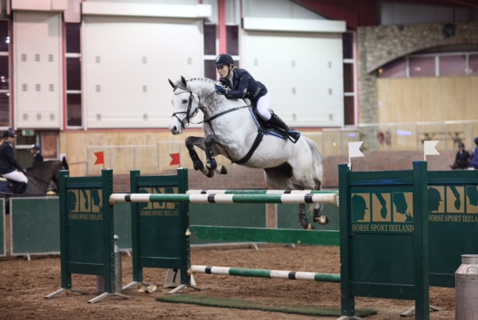
My Top three favourite horses:
- Best Touch
- Garagange
- Rehab
Best Touch (retired); – He is a 168 cm 13 year old bay gelding by Irish Olympic stallion Touchdown. He was produced by me, from novice to Grand Prix level. Best Touch retired in 2013 due to injury.
Garagange; - He is an 8 year old grey stallion by Conquest van de Helle (Corrado 1) out of a mare by Skippy II (Galoubet). He is owned by my father, Gary and was purchased in Belgium as a 3 year. He was broken by us, and I have produced him to Grand Prix level. He is an attractive stallion standing 17hh with blood, scope and jump to burn. He also has an excellent temperament for a stallion, and I am privileged to have him to compete upon.
Rehab; - She is a 10 year old mare by VDL Douglas out of a mare by Irish Olympic stallion Touchdown, & is owned by my mother. She was bought as an unbroken 4 year old and has been produced to Grand Prix level by ourselves at Ballymoss Stud. Whilst only standing 158cms, she has a great stride, powerful jump and tremendous scope.

Sponsorship
In 2014, I have been lucky enough to be sponsored by Oonagh Kennedy at Kennedy Equine Centre. Oonagh is a stockist for many top equestrian brands for both horse and rider including Tucci, Equiline, Manfredi & Christina Sport. I look forward to show casing these products; I am wearing their clothes in all my jumping photos. You can find all the products online at www.teamkec.com

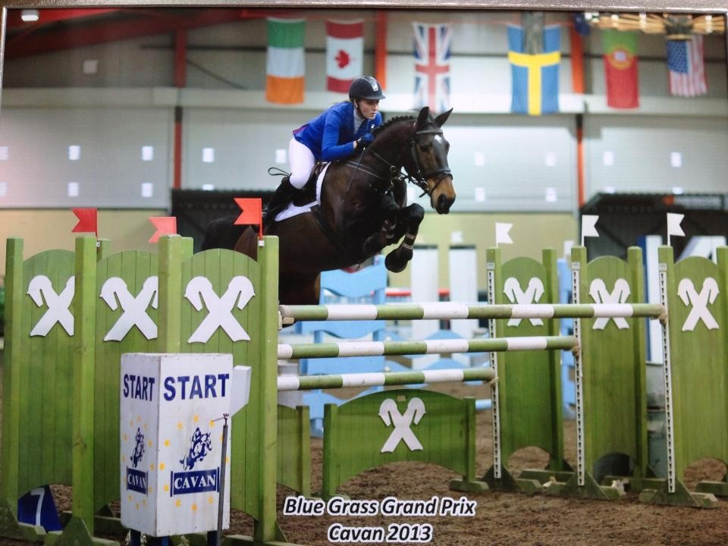
Career to Date:
I started working alongside my mother at Ballymoss Stud in 2010 and now have taken over the day to day management of the operation. I am so grateful for the help and support of both parents and to continue training and improving both my horses and myself.
2009 I qualified for Balmoral in the 1m30 National class on Best Touch and finished 7th. This experience was amazing - walking into the main arena at 18, with a huge audience and atmosphere, it was unforgettable.
2010; I won the 'Leading Young Rider' title at the National Balmoral Championships, I achieved this with; Best Touch and Alida van de Boswinning.
Cavan International in November 2010, I was selected as part of the Ulster Region Young Rider 1m20 team with Alide van de Boswinning where we won team gold. From here I then retired Alide van de Boswinning to become a broodmare after numerous wins at 1m20 and 1m30 level.
2011 – 2012; I spent a period of my time producing young horses – ‘Rehab’ and ‘For Deus van Oosterwyck’ up to mini GP level and getting various placing. ‘For Deus’ was sold to California in 2012 and is based in Olympic rider, Hap Hansen's competition yard.
2013 I was fortunate to have been selected for the H.S.I / SNI Talent Development Training programme in the Ulster Region. I am grateful to have received this opportunity to receive the benefit of knowledge, skill and experience of some of Ireland’s best Coaches.
2014; so far, I have had a successful start to the season. I have a couple of nice young horses to produce alongside Rehab and Garagange, who are now at Grand Prix level.
This season I hope to continue producing quality horses for my loyal owners and myself.
It is my aspiration that Garagange will continue to compete into National Grand Prix level and plan some International shows with him. Rehab, will be an excellent support horse to take away with him, for the highly competitive International Speed classes.

Other Interests
I enjoy keeping fit and regularly attend the gym. As a rider, my fitness is as important as my horses’ fitness. I also have a great love for hockey; I played at 1st X1 level for Wallace High School, and went on to become a strong member of Lisnagarvey Hockey club in Hillsborough. However, if I need to make a choice, and focus on one sport – there’s no contest, it will always be my first love, horses and show jumping.
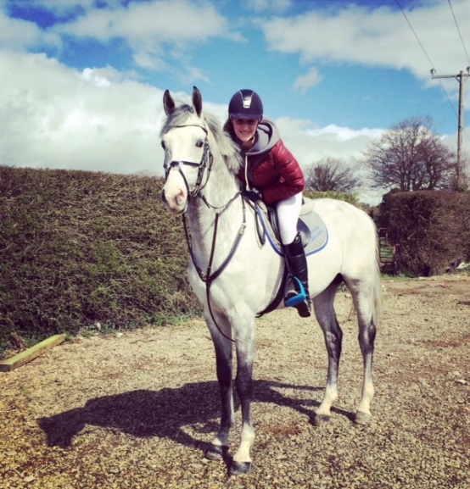
Contact Me:
Address: Ballymoss Stud, Lisburn, Co. Antrim, BT27 6UX
Website: www.ballymossstud.com
Email: pstewart90@btinternet.com
Facebook: Ballymoss Stud
Mobile: 004475 4103 7688
The Future:
I currently have a couple of vacancies for competition livery should any owners wish to their horses produced and competed professionally but sympathetically to its full potential.

