Name: Suzanne Posnett
Age: 31
DOB: 15/06/1983
School: Bangor Academy
Education: BA Hons Degree in Business Management
Home: Comber, Co. Down
TD Discipline: Show Jumping

I was born on the 15th June 1983 and grew up in Donaghadee but moved to Comber in 2007. I went to Bangor Academy where I studied my GCSEs and then I did a GNVQ in Business Studies and another in Information Technology.

After completing both GNVQs with Distinctions I then went to North Down And Ards Institute and completed a HND in Business Studies and then went on to do a
Bachelor of Arts Honours Degree in Business Management, where I graduated with a 2.1.

After all that studying - I decided to take a year out and focus on horse’s full time. Thankfully things worked well and I haven’t looked back!

In 2007 I moved from Donaghadee to Comber. I had grown up with a beach at the bottom of our garden which was very beneficial for the horses and the ponies, but my parents offered me the opportunity to expand my business. The new premises have given me 10 stables, a number of turnout paddocks, a sand school, a horse walker, and fields to ride the horses in and quiet hacking. It is a very quiet part of the world and the horses are all very relaxed!

My major achievements and accomplishments:

- Pony Working Hunter Championship in RDS in 2000
- 6 Year Old Championship in National Balmoral in 2007
- 4th in the 7/8 Year Old Championship at the National Championships in Barnadown in 2008
- 4th in the Boomerang Championship in Millstreet in 2007
- I represented Ireland at The World Young Horse Championships in Lanaken in 2007
- Leading Rider at National Balmoral in 2011
- 6/7 Year Old Championship in Portmore 2013
- Won and placed in numerous Ulster Grand Prixs
- Wins in Scotland and England

Sponsors:

I am very fortunate to have help from a number of sponsors and I appreciate the help and support they give me. I am proud to be associated with them as they are all experts in their fields, and this allows me to have a knowledgeable point of contact when needed. My current sponsors are:

- Bluegrass Horse Feeds,
- Horse First Supplements, and
- Botanica.

My top 3 horses are:

- Maxim Van Overis Z who is owned by my mother Pamela Posnett
- Butuela who is owned by David Prentice BMW
- Carrickview Gin And Tonic who I own myself

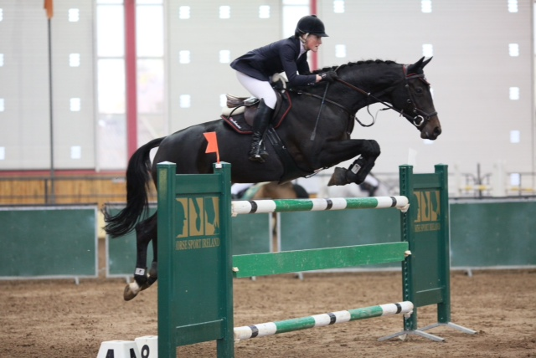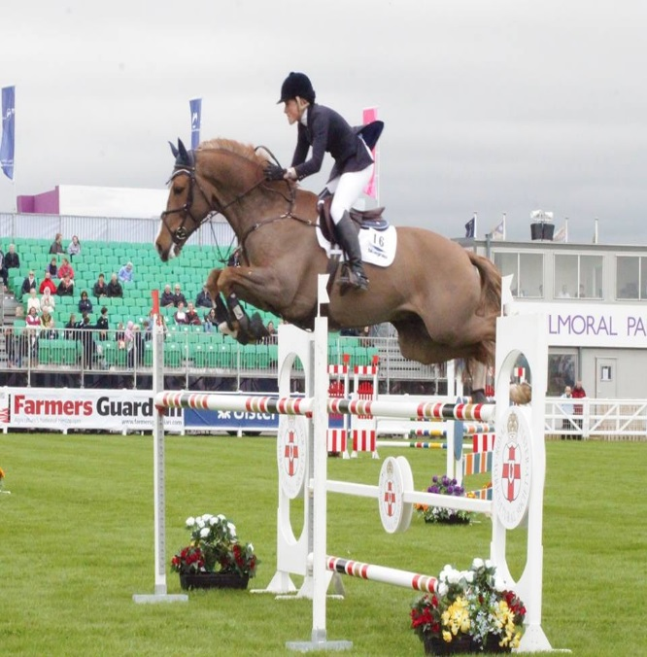

Maxim Van Overis Z is an 8 year old gelding owned by my mother Pamela. I bought him as a 3 year old and have produced him throughout. When I was jumping in Lanaken we were introduced to Gerald Lenaerts who owns Stud Farm Van Overis. He showed me his 2 year old horses and I was taken by Maxim and bought him the following year. He has been produced slowly as he has shown a lot of talent and is now ready to move up to the bigger competitions. He has been consistent in the age classes and competed in a few of the Ulster Grand Prix leagues last year and this will lead to the National Grand Prix League this year. He was 2nd in the first Bluegrass Ulster Region Summer Tour this year and is qualified for the 1.35 class in Balmoral.

Butuela is an 8 year old mare owned by David Prentice BMW. I was very fortunate in 2013 to secure the rides on David Prentice’s horses. This has been a great opportunity and one that I was very excited about. When I took this mare on she had been produced well and was ready to jump her age classes. She is showing a lot of talent and was placed in some of the Ulster Grand Prix Leagues last year and was placed in the first Bluegrass Ulster Region Summer Tour this year. The aim is to move up to the National Grand Prix League this year.

Carrickview Gin And Tonic is a 6 year old gelding who I own myself. I was sent this horse as a 4 year old by his previous owner John Haughey. I liked the horse so much that I bought him myself! He was a weak horse but has grown into himself and turned into a lovely horse who is competing in his age classes. He is qualified for Balmoral in the 6 year old class and is being aimed at the Horse Sport Ireland age classes.

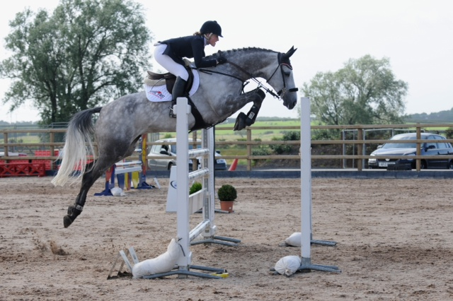 | 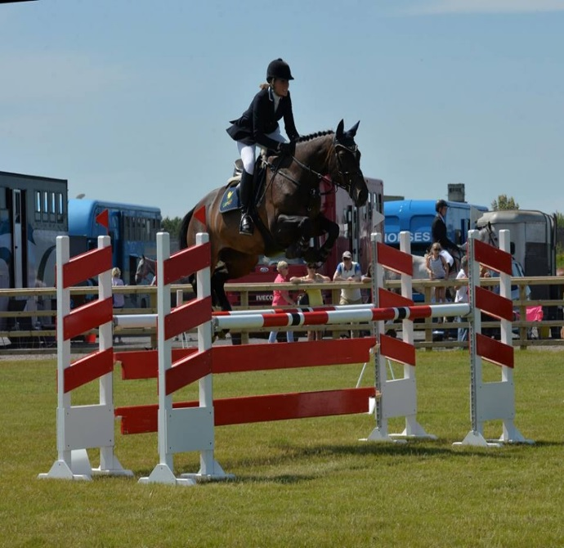

I have been very fortunate as my parents provided me with good ponies which I competed in showing and working hunter classes. I then decided to do 2 years in the Eventing sphere but then decided to focus on show jumping. I have had a number of lovely horses to produce and there are two that stand out in my mind.
Touchable - who I had from a three year old up to an 8 year old. She was produced through the age classes jumping in Dublin Horse Show and Millstreet finals gaining placing. I represented Ireland on her as a 7 year old, and jumped her in a few National Grand Prix and a Premier Grand Prix. This mare was sold to England and has gone on to achieve a number of successes representing Great Britain on Nation Cup Teams.
Karmijn is another special horse who I have had for 9 years and won a lot of classes on. She is 22 years of age now and still going! She is a very special lady and a fantastic 1.20 speed horse. She is very determined and strives to win!

Contact Me

Email: suzanneposnett@gmail.com
Facebook: I have a personal facebook page Suzanne Posnett. I use this to promote results I have achieved, to thank and acknowledge sponsors and upload action photographs.
Twitter: I have got a twitter page @SuzannePosnett

