We recognise that implementation is an ongoing process. We are committed to the implementation of this Child Safeguarding Statement and the procedures that support our intention to keep children safe from harm while availing of our services.

Our Child Safeguarding Statement has been prepared in accordance with the legislature requirements contained in the Children First Act 2015 and the Children (NI) Order 1995 and as required by our organisation.

**This Child Safeguarding Statement will be reviewed every 2 years.**

**The Horse Sport Ireland Mandated Person, who under the Children First Act 2015 has a legal obligation to report harm of children is Ciara Gorman.**

**E:** [safeguarding@horsesportireland.ie](mailto:safeguarding@horsesportireland.ie)

**M:** 087 2592 195

Child Safeguarding Statement 2018

**Chairperson Signature**

**Children Officer Signature**

**_______________________ __________________________**

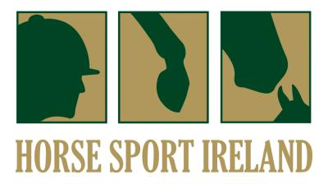

We have the following procedures in place as part of the Horse Sport Ireland Safeguarding Code in addition to our Risk Assessment outlined above:

* Procedures for the management of allegations of abuse or misconduct by staff or volunteers against a child availing of our activities.
* Procedures for the safe recruitment of staff and volunteers to work with children in our activities.
* Procedures for access to child safeguarding training and information, including the identification of the occurrence of harm.
* Procedure for the reporting of child protection or welfare concerns to the Statutory Authorities.
* Appointing Children’s Officers at Affiliate level and Branch/Club/Regional level who are the point of contact in respect of Safeguarding for the relevant body and for this statement

We have completed a Safeguarding Risk Assessment that indicates the areas of potential risk of harm, the likelihood of the risk occurring, and gives the required policy, guidance or process documents required to alleviate these risks. The list of risks identified are contained in the following categories: Club and Coaching Practices; Complaints & Disciplinary; Reporting Procedures; Use of Facilities; Recruitment; Communications; and General Risk of Harm.

Horse Sport Ireland provides sporting activities and opportunities for children and young people through participation in our Affiliates and their clubs, branches and regional events and with our representative teams at national level. Horse Sport Ireland is committed to safeguarding children and young people. All our affiliated bodies, and their member bodies work under the guidance and policies of our Safeguarding Policies and Procedures. All our volunteers and staff working with children throughout the organisation, seek to create a safe environment for children and young people to participate in equestrian sports.

INSERT

LOGO

HERE