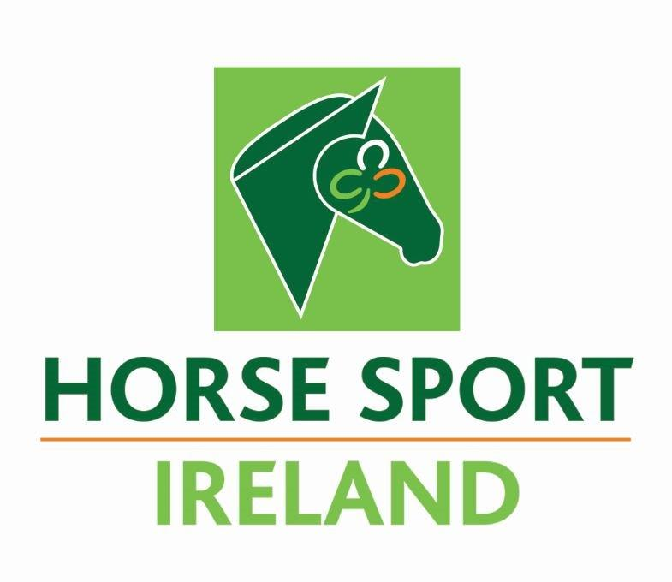

Horse Sport Ireland
Affiliate Application Form

Name of Organisation:

We declare that the information provided in this Application Form is true and accurate. On behalf of our organisation, we hereby apply for Affiliation to Horse Sport Ireland.
The declaration of information must be hand signed by two of the following board members of your organisation – Chairperson, President, Secretary or Treasurer.
Only signatures of Board members will be accepted. You have the option of scanning in the page and emailing with your application form or posting the original copy.

Signed: ______________________________________ Date: _____________________
Chairperson/President

Signed: ___________________________________ Date: _____________________
Secretary/Treasurer

You must ensure that the information provided in this Application Form is accurate.
You must ensure that the documentation to be provided with this Application Form is submitted, failure to do so will delay consideration of the grant application and may result in the application being refused.

AFFILIATION APPLICATION FORM
Your application for MUST include the following:
- Your organisation’s current Strategy Document
- Staffing details for you’re Organisation (if applicable) – name, role, employment status of paid employees. State whether permanent, part time or contract (specify duration length) within application
- Composition of Board and roles of each Board position. Percentage of female Board Members must be provided. Board member contact details also must be provided, NGB contacts details will not be accepted
- Your organisation’s Constitution or Memorandum & Articles of Association (if Company Limited)
- Unqualified independent audited financial statements for each of the last three (3) fiscal years.
- A summary of active paid membership numbers and clubs as outlined within application.
- Code of Ethics & Garda Vetting Compliance
- Completed application forms to be sent to HSI Sport & Recreation Manager, Paul Hayes, phayes@horsesportireland.ie

Please note that if you require more rows or columns in the tables appearing in the Application Form, please place your cursor on the outside of the last row and press ‘Enter’ to add more lines. Additional documents will not be accepted.
AFFILIATE CONTACT DETAILS
Affiliate Organisation | [Name]
Registered Address | [Address]
Contact Details | [Telephone] | [Mobile] | [Email]
CEO /General Manager (if applicable) | [Name]
Address | [Address]
Contact Details | [Telephone] | [Mobile] | [Email]
Contact for Horse Sport Ireland* | [Name]
Address | [Address]
Contact Details | [Telephone] | [Mobile] | [Email]
Contact for Public | [Name]
Address | [Address]
Contact Details | [Telephone] | [Mobile] | [Email]

Affiliate General Information
- Provide a brief overview of the activities of your Organisation. Please feel free to add any information you deem relevant. (Please refer to Section 2 of the Recognition Criteria document).

- Does your Organisation have a Strategic Plan in place? Y / N
  - If yes, please indicate the period of time the Strategic Plan covers: _______________
  - If yes, please include of a copy of it with the application.

- Does your Organisation have paid staff in place? Y / N
  - If yes, please complete the table below.
Staff Name | Role | Employee Status (Perm, P/T, Contract + duration)

- Please provide the full details of all Current Board Members in the table below.
Board Member | Please insert gender* | Specific role | Contact details of Board member  (email &telephone details) | Duration on Board | Skills/Qualifications
(to add more lines, place your cursor on the outside of the last row and press ‘Enter’)
*Please use the following for gender: Female, Male, Other/Non-binary, prefer not to say
- Can you confirm that the duration of all board members is in line with your Constitution/M&A board rotational guideline. Y / N
- Please provide the overall gender breakdown of your Board in percentage: ___________
- If your Board has less than 30% females at present, please include a summary of any plans the board have to address this?

- Please state the date of your next Annual General Meeting (AGM)? ___________
- What date was you Constitution or Memorandum & Articles of Association last updated? (Please provide a copy of this with your application) ___________
- Does your organisation have independently audited financial statements for the last three (3) fiscal years? Y / N
  - Please provide copies with your application.
- Does your organisation operate from Ireland? Y / N

AFFILIATE MEMBERSHIP STATUS

We will require your membership numbers to support your application. This information is important as it helps us to further understand your Organisation and in general the development of equestrian sport in Ireland. Under the Data Protection Act you will not be required to release the individual names of your members; however, you will be required to provide your membership details in the tables below.

Please note that if your Organisation is an Umbrella Body and features many individual disciplines or organisations, please complete the below tables for the total number of members.

Membership Breakdown
Please state when registration is open (e.g., Jan-Dec, Sept-Aug, members can register at any time of the year).

Time of year when registration is open

We would like to understand the geographical spread, gender, disability status and age breakdown of your core members for the past year (i.e., individuals who are affiliated with clubs or directly with your Organisation).

Gender Breakdown | Number | Percentage of Membership
Individual members (Male) |  | %
Individual members (Female) |  | %

Age Breakdown | Number | Percentage of Membership
Individual members (Over 18) |  | %
Individual members (Under 18) |  | %

Disability Breakdown | Number | Percentage of Membership
Members with a Physical Disability |  | %
Members with an Intellectual Disability |  | %
Members with Autism |  | %
Members who are Blind or have a vision impairment |  | %
Members who are Deaf or Hard of Hearing |  | %
Other |  | %

Cost of Membership
Please list all of the annual membership categories that are available in your Affiliate and the individual cost per member (e.g., Annual Adult, Annual Senior, Annual Junior, Student, Disability, U16 Recreation, Competitive, One-day licence, etc.) Please feel free to add additional lines in the table as required.

Membership categories | Individual Cost per Member €
 | €
 | €
 | €
 | €
 | €
 | €
 | €
 | €
 | €
 | €

All-Island or 26-County NGB?
Is your NGB an All Island or 26 County Body?

Geographical Data | Connacht | Leinster | Munster | Ulster | Total
Number of affiliated clubs / organisations / regions as applicable

Number of individual members (excluding schools, universities/colleges, temporary members, one-day licences, etc.)

SPORT IRELAND GOVERNANCE CODE

- Is your organisation aware of the Sport Ireland Governance Code? Y / N

- Is your organisation compliant or on the journey to compliance with the Sport Ireland Governance Code? Y / N
Horse Sport Ireland will separately be seeking further information on the status of your organisation’s adoption of the Governance Code in due course. Compliance with the Code is not a requirement of Affiliation however Horse Sport Ireland will require a commitment from potential Affiliates to become compliant with the Code.

SAFEGUARDING & GARDA VETTING COMPLIANCE

Horse Sport Ireland’s Code of Ethics & Good Practice for Youth & Vulnerable Adults in Our Sport is developed in line with Sport Ireland’s Safeguarding Guidance for Children & Young People in Sport and is underpinned by Children First National Guidance 2015 and current legislation. Horse Sport Ireland require all Affiliates to appoint the following roles:
- National Children’s Officer.
  - should complete all three Safeguarding courses within a 6-month period of taking up this role within your organisation.
- Designated Liaison Person.
  - should complete the Safeguarding 1 and Safeguarding 3 courses within a 6-month period of taking up this role within your organisation.
- Mandated Person (where applicable).
  - The Children First Act 2015 places a legal obligation on certain people, many of whom are professionals, to report child protection concerns at or above a defined threshold to Tusla - Child and Family Agency. Mandated Person(s) are people who have contact with children and/or families and who, because of their qualifications, training and/or employment role, are in a key position to help protect children from harm.
Please note in order to comply with the commencement of the Children First Act 2015 the following information is required:
- Each Affiliate must have a ‘Child Safeguarding Statement’ similar to existing sports policy within 3 months of the Act commencing.
  - Does your Organisation have a Child Safeguarding Statement in place?
Y / N

- The organisation must name a Designated Liaison Person and Mandated Person (where applicable to organisations under the Children First Act 2015).
  - Has your Organisation appointed a Designated Liaison Person?
Y / N

Please provide the most up to date details on the following positions within your organisation:
National Children’s Officer: | [Name]
Address: | [Address]
Contact numbers: | [Telephone]
Email address: | [Email]

Designated Liaison Person (if different from NCO): | [Name]
Address: | [Address]
Contact numbers: | [Telephone] | [Mobile]
Email address: | [Email]

Mandated Person (where applicable to organizations under the Children First Act 2015): | [Name]
Address: | [Address]
Contact numbers: | [Telephone] | [Mobile]
Email address: | [Email]

National Vetting Bureau Act 2012-2016:
If your organisation is considered a Relevant Organisation under the National Vetting Bureau (Children and Vulnerable Persons) Act 2012 to 2016, please highlight the current process you have in place to ensure compliance?

